**OLD**

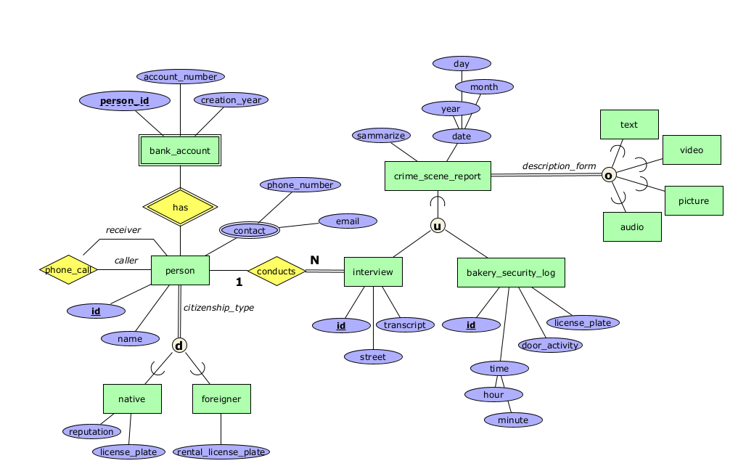

**NEW**

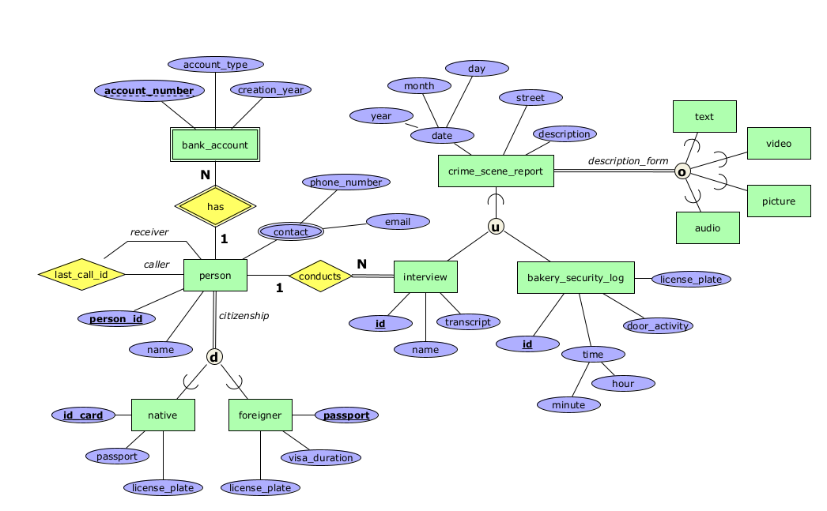

*Change attribute names:*

* person
  1. id → person_id
  2. citizenship_type → citizenship
* crime_scene_report
  1. sammarize → description
* foreigner
  1. Rental_licence_plate → licence_plate
* interview
  1. street → name

(Simplified naming, easier to understand and read)

*Change attribute:*

* person
  1. phone_call → last_call_id (Rethink Recursive and change it to a relationship that can be implemented in RDB)
* bank_account
  1. person_id → account_number (Account_number is the PK of the weak entity, so it can be found in the person)
* crime_scene_report
  1. + street (Increased to 3 attributes)
* native (Increased to 3 attributes)
  1. + id_card
  2. + passport
  3. – reputation
* foreigner (Increased to 3 attributes)
  1. + passport
  2. + visa_duration